SCHEMES OF WORK
Key Stage: UKS2 Community Topic: How things work Term: Spring 2021 Focus: Money Class: Mulberry
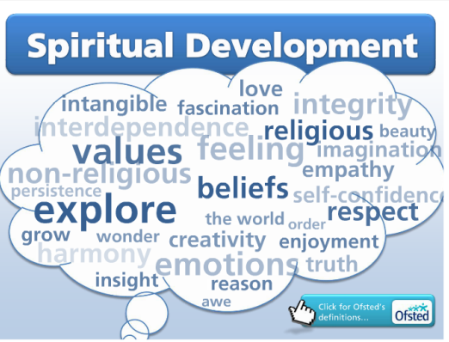
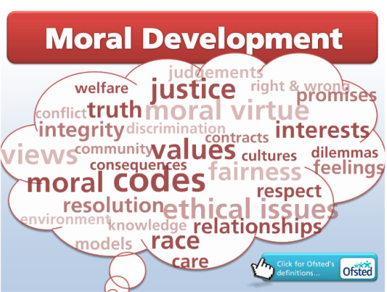
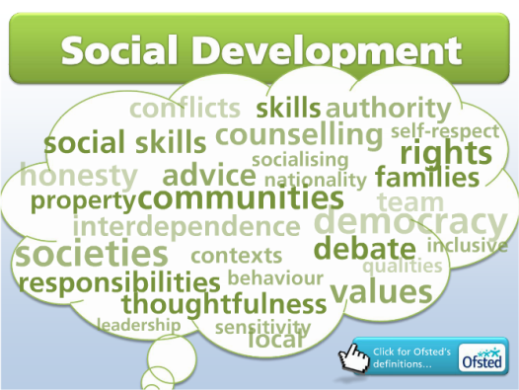
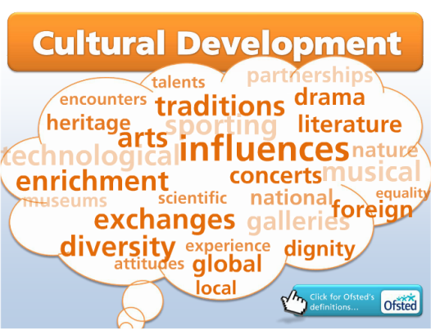

Learning Objectives | End Points | Activities | Notes
Pupils will:  - I understand how archaeologists and historians collect and use artefacts to help them learn about the past.  - I understand what it means to be part of a community.  - I have learned about the work of a growing number of local and national charities and have taken part in fundraising activities. | Pupils can:  L: React excitedly when provided with a new activity.  Reacts excitedly to a change of environment when provided with new experiences  Demonstrates a brief interest in objects in their immediate environment when encouraged by a member of staff  Demonstrates a brief interest in sights in their immediate environment when encouraged by a member of staff  Explores a desired object with their hands for up to 10 seconds when provided with a variety of objects  Explores small objects with their senses when they are placed in front of them  M: Communicates consistent preferences with emotional responses when choices are provided  Interacts with a common object briefly when its name is spoken or signed  Looks at an object when it is named  Matches objects based on obvious criteria, e.g. when a member of staff picks an item, the individual finds ones that match  H:  Answers Who, What, Where questions.  Shows awareness that somethings always happen-e. Water makes paper wet.  Looks at a globe and knows its shape and what is represented on it.  Uses term “a long way”. | Launch- what are charities (international or national) and what do they do?  Research what a charity is and look at what they do:    World Water Day 22/3/21 https://www.twinkl.co.uk/resource/t-tp-308-eyfs-all-about-world-water-day-information-powerpoint  Different ways of collecting water  https://www.wateraid.org ( international and UK site)  Also link into UNICEF Rights Respecting School. Article 24.  Use different bowls of water to show clean and dirty water. Which water would you drink?  Use taps in school to see if water is clean/dirty?  Explore different ways of getting clean water. In class, make filters and get students to clean water. Also, could buy water purification tablets and show them these. ( check health/safety)  Collect samples of water throughout the school. Is it from a clean source, that is either tap or bottled water, or from a dirty source like water from a drain, pond, river or puddle?  Compare the water samples by holding them up against each other. Look how dirty the water is, and see if it can be made cleaner by passing it through a number of colanders with blotting paper, tea strainers and other mediums.  What happens if you only have dirty water?  Wash hands in dirty water-are they clean?  Link to COVID-need to wash hands properly.  Nirinasoa’s Walk.  Nirinasoa lives in Madagascar-where is this. Find on a world map.  Climate-Tropical.  Ways of moving water. What makes best container?  Use different sized sponges to soak up water from a paddling pool – where do you get the water from, taps, hose, outside tap (what can we use to effectively carry water – experiment with different items, paper bags, colander, carrier bags, buckets, plastic bottles, plastic cups etc.  Have a race between two teams who decide how to carry the water from one large paddling pool to another. Make sure you make this really fun and bringing in a time restriction (WE ONLY HAVE 5 MINUTES!!!) will crank up the tension.  Schools Challenge-how far can pupils carry a bucket of water? Could do a school challenge.  Make a Tippy Tap.  Bible story- sharing, kindness and compassion  Feeding of 5000 ( Loaves and Fishes) https://www.twinkl.co.uk/resource/t2-r-149-jesus-feeds-the-5000-bible-story-powerpoint  Use substitute fish and loaves to share onto different plates and see how far it can go.  Could generate display work from this.  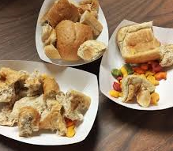  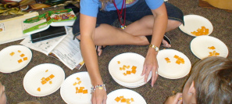  What can we do as a class?  Think of a way to contribute to a local charity  Buddhism-Water for cleanliness.  Wesak-Buddisdt festival. 8.4.2021.  One aspect is to wash statutes of Buddha in scented water-  History-Dalai Lama. Who is He and what does he do.  END Activity  Think of a way to contribute to a local charity  SILKLIFE FOODBANK - Macclesfield  Food bank collecting  Pupils to work together as a team - to collect food items that will be eventually sent to a food bank.  To research food banks and their purpose.  To design their own charity name and logo for the collection. To design a flyer to explain about the food collection and how each class is going to achieve the collection. To advertise on the school website and Facebook page.  To organise boxes for Silk, Granellis and Mulberry and to explain how the collection will work.  Ideas:  - Each class to be allocated a type of food (so we don’t duplicate) i.e Silk – Pasta and Tins, Granelli – Toiletries etc  - Pupils in each class to bring in one item from home for the boxes and to sort the items into the relevant box. Pupils to decorate and design their own boxes for class.  Pupils to explore some of the food that they have collected for the food bank. To cook it, taste it, smell, and explore texture.  Once all boxes have been filled, Mulberry to check and sort and to deliver the boxes to a local food bank.  .  . | Curriculum Links:  English – key vocabulary, storytelling,  roleplay  Maths – money, charity collection  Health & Safety & Safeguarding  Risk assessments for all visitors/trips  Ensure handwashing procedures for handling any animals  Choking hazards of any small parts/toys etc.  SMSC:  Spiritual: sense of feeling good about ourselves when we help and give thanks to others  Social: use of a range of social skills in working with others and helping others.  Cultural:  Learning about  Preparing for Life in Modern Britain:  Educational Visits:  visits from school staff  Community visit to give to charity  Web & Software Links:  https://www.twinkl.co.uk/resource/t2-r-149-jesus-feeds-the-5000-bible-story-powerpointhttp://www.cre8macclesfield.org/  WaterAid-Schools Challenge.  10 Amazing facts about Madagascar.  The Schoolrun-Buddism.  Twinkl-Dalai Lama.

