SCHEMES OF WORK
Key Stage: Three Subject: Challenge Topic: Global Warriors – Recycling Term: Spring 2020 Class: Arighi’s
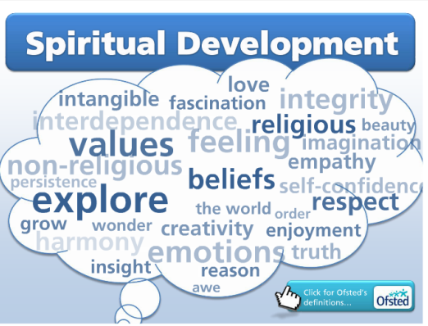
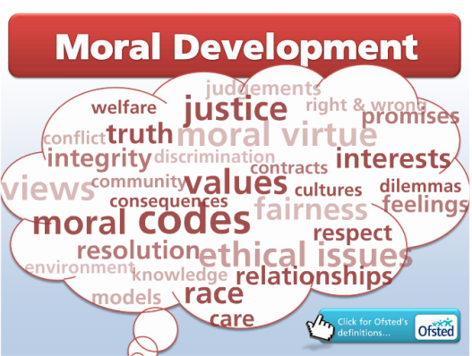
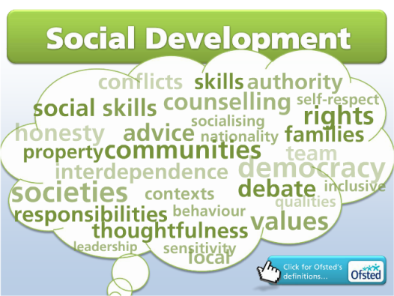
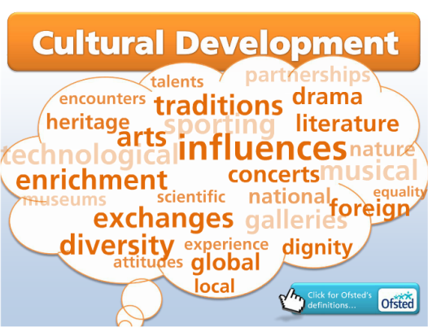

Learning Objectives | Learning Outcomes | Activities | Notes
- I can stick pieces together in different ways to make strong products.  - I can use tools and other equipment safely, with supervision where appropriate.  - I can use technology to present my learning and ideas in a range of ways.  - I can use technology to capture and create images and sound.  - I have learned about animals including humans, focusing on reproduction, nutrition and exercise.  - I can compare uses of everyday materials and how they can be changed.  - I have explored how packaging and advertising are used to sell products.  - I have created packaging and adverts for products.  - I can speak for myself to make sure my opinion is heard or so I can get thigs I want or need. | Pupils Can:  L: Follows a simple one- or two-key word instruction when accompanied by gestures and context  Identifies common objects by pointing/looking at them when they have been named  Interacts with a common object briefly when its name is spoken or signed  Passes an object with their hands when they have been prompted by a member of staff  Matches objects based on obvious criteria, e.g. when a member of staff picks an item, the individual finds ones that match  Reacts positively to a new activity when provided with new experiences  Explores an object for five minutes when working coactively  Handles rough/soft objects with interest when provided with a variety of textures  M: Gives creatures an appropriate name, e.g. bird if flying  Finds the birds, fish or people from a range of pictures  Describes simply what they have seen an animal do or eat, e.g. by saying the word, picking a picture, imitating the action or noise, etc.  Communicates what they can see in the environment  Comments on and asks questions about the natural world  Sorts objects by a given criteria when contrasts are obvious  Starts to be able to find an object with one specific characteristic, e.g. an object that is: green, hard, little, etc.  Identifies one property of a material being handled, e.g. cold, hard, shiny, etc.  Sorts materials into a simple group, e.g. rough  Identifies if they can pull, bend, or squash a material after manipulating it  Selects materials to use from a given collection  Chooses the correct familiar tool for a task from a group of three, e.g. paintbrush, scissors, glue  Chooses the correct familiar material for a task from a group of three, e.g. cardboard, paper, string  Tracks movement across a screen reacting at appropriate points  H: Names a range of wild animals  Communicates about the different foods animals eat  Describes animals that they have seen and the habitats in which they saw them  Investigates a less well known habitat in more detail to discover the types of animals which live there and how they use their habitat  Discusses what they are going to do, including how and why in simple terms  Describes the textures of materials and makes simple links to objects made from a material, e.g. clothes – soft, smooth  Identifies a range of objects made of metal, plastic or wood  Identifies a range of items that are made from a specific material  Classifies easily observable properties of materials with support  Folds, tears and cuts paper and card  Hammers gently with support  Compares tools, e.g. a Phillips and flathead screwdriver  Joins different materials  Discusses what they are going to do, including how and why in simple terms  Identifies some reasons why a specific material is used for a task, e.g. paper for a parcel  Describes with familiar, simple key words what actions they took or tools they used to create a finished product  Creates work that includes pictures and text  Uses cameras to take still and moving pictures  Works with a member of staff online | Launch activity: Visit a wildlife sanctuary such as Coombes Valley in Leek to learn about conservation and why it is necessary.  Story- One plastic bag – collect OOR, make symbols and pictures to make a sensory story from the book. Start each session with this story.  Explore information about the harm human waste materials can have on animals – look at the problems plastic is causing in the oceans – changes to the habitat, effecting fish in their reproduction, nutrition etc  Go to ‘Kids against Plastic’ for some resources/workshop ideas on plastic & the oceans. (Link in Notes). There are some power Points with lovely photos of animals and the impact plastic has on them as well as links to video clips  Look at what humans are doing to our local environment – reducing green spaces – building new houses – reducing habitats for native species such as hedgehogs, native birds and insects. Look at what these native species need to thrive – enough food to stay well & feed their young, enough shelter to mate & reproduce.  Read the Twinkl book ‘The messy Magpie’ & use some of the resources to reinforce the importance of caring for our environment & to introduce recycling  Look at recycling in school and how it can be improved – walk round school – can they find the recycling bins (bins in the staff room, bags in the work room and office). Take photos of the bins/bags – print them out & discuss whether they think there are enough bags/bins for everyone.  Play the ‘Junk Jumble Recycling Game’ on Twinkl – sorting items into recycling bins by their materials.  https://www.twinkl.co.uk/go/resource/tg-ga-59-twinkl-green-week-junk-jumble-recycling-game  Email the council to point out problems they have identified and to ask for extra recycling bins. Involved Wendy and Eco-Council.  Start a campaign to encourage all staff and pupils to recycle. Design and make posters using recycled paper to advertise the school’s new recycling ethos.  Use IT to create a presentation for governors about improving recycling & why it should be done. Invite class link governor in to see the presentation, look at the posters and listen to ideas about increasing recycling in school.  Research/watch video clips of what happens to our recycling – where do the things we recycle go & what happens to them? Link to different materials and their properties.  Begin to think how things we throw away can be recycled into items we can use to help the environment. Collect materials for recycling and use them to enhance the school garden  Landing activity: Create a mini conservation area in school grounds from entirely recycled products.  Include bird feeders (various ideas)  and bird boxes (wooden kits) | Curriculum Links:  English – key vocabulary – recycle, plastic, metal, cardboard, paper, materials, conservation, wildlife  Reading - follow, sequence & understand the story, one plastic bag  Writing – create posters – write key words or select key symbols to go one their posters.  Maths – sorting items by specific criteria - materials  Health & Safety & Safeguarding  Ensure all risk assessments are carried out before any off site visits  Make sure all recycling is safe for pupils to handle  Close supervision when pupils are creating bird boxes using tools  SMSC:  Spiritual:  - ability to be reflective about their own beliefs, religious or otherwise, that inform their perspective on life and their interest in and respect for different people’s faiths, feelings and values  - sense of enjoyment and fascination in learning about themselves, others and the world around them  - use of imagination and creativity in their learning  - willingness to reflect on their experiences  Moral:  - ability to recognise the difference between right and wrong and to readily apply this understanding in their own lives  - understanding of the consequences of their behaviour and actions  - interest in investigating and offering reasoned views about moral and ethical issues and ability to understand and appreciate the viewpoints of others on these issues.  Social:  - use of a range of social skills in different contexts, for example working and socialising with other pupils, including those from different religious, ethnic and socio-economic backgrounds  - willingness to participate in a variety of communities and social settings, including by volunteering, cooperating well with others and being able to resolve conflicts effectively  Cultural:  - understanding and appreciation of the wide range of cultural influences that have shaped their own heritage and those of others  - understanding and appreciation of the range of different cultures within school and further afield as an essential element of their preparation for life in modern Britain School  Preparing for Life in Modern Britain:  - acceptance and engagement with the fundamental British values of democracy, the rule of law, individual liberty and mutual respect and tolerance of those with different faiths and beliefs; they develop and demonstrate skills and attitudes that will allow them to participate fully in and contribute positively to life in modern Britain.  - knowledge of Britain’s democratic parliamentary system and its central role in shaping our history and values, and in continuing to develop Britain  Educational Visits:  Coombs Valley Conservation park  Web & Software Links:  https://www.recycle-more.co.uk/school-zone/activities-for-schools-/primary-activities  https://www.twinkl.co.uk/resources/ks2-the-environment/ks2-the-environment-recycling/activities-recycling-the-environment-topics-key-stage-2  http://www.kidsagainstplastic.co.uk/learn/lesson-guides/

