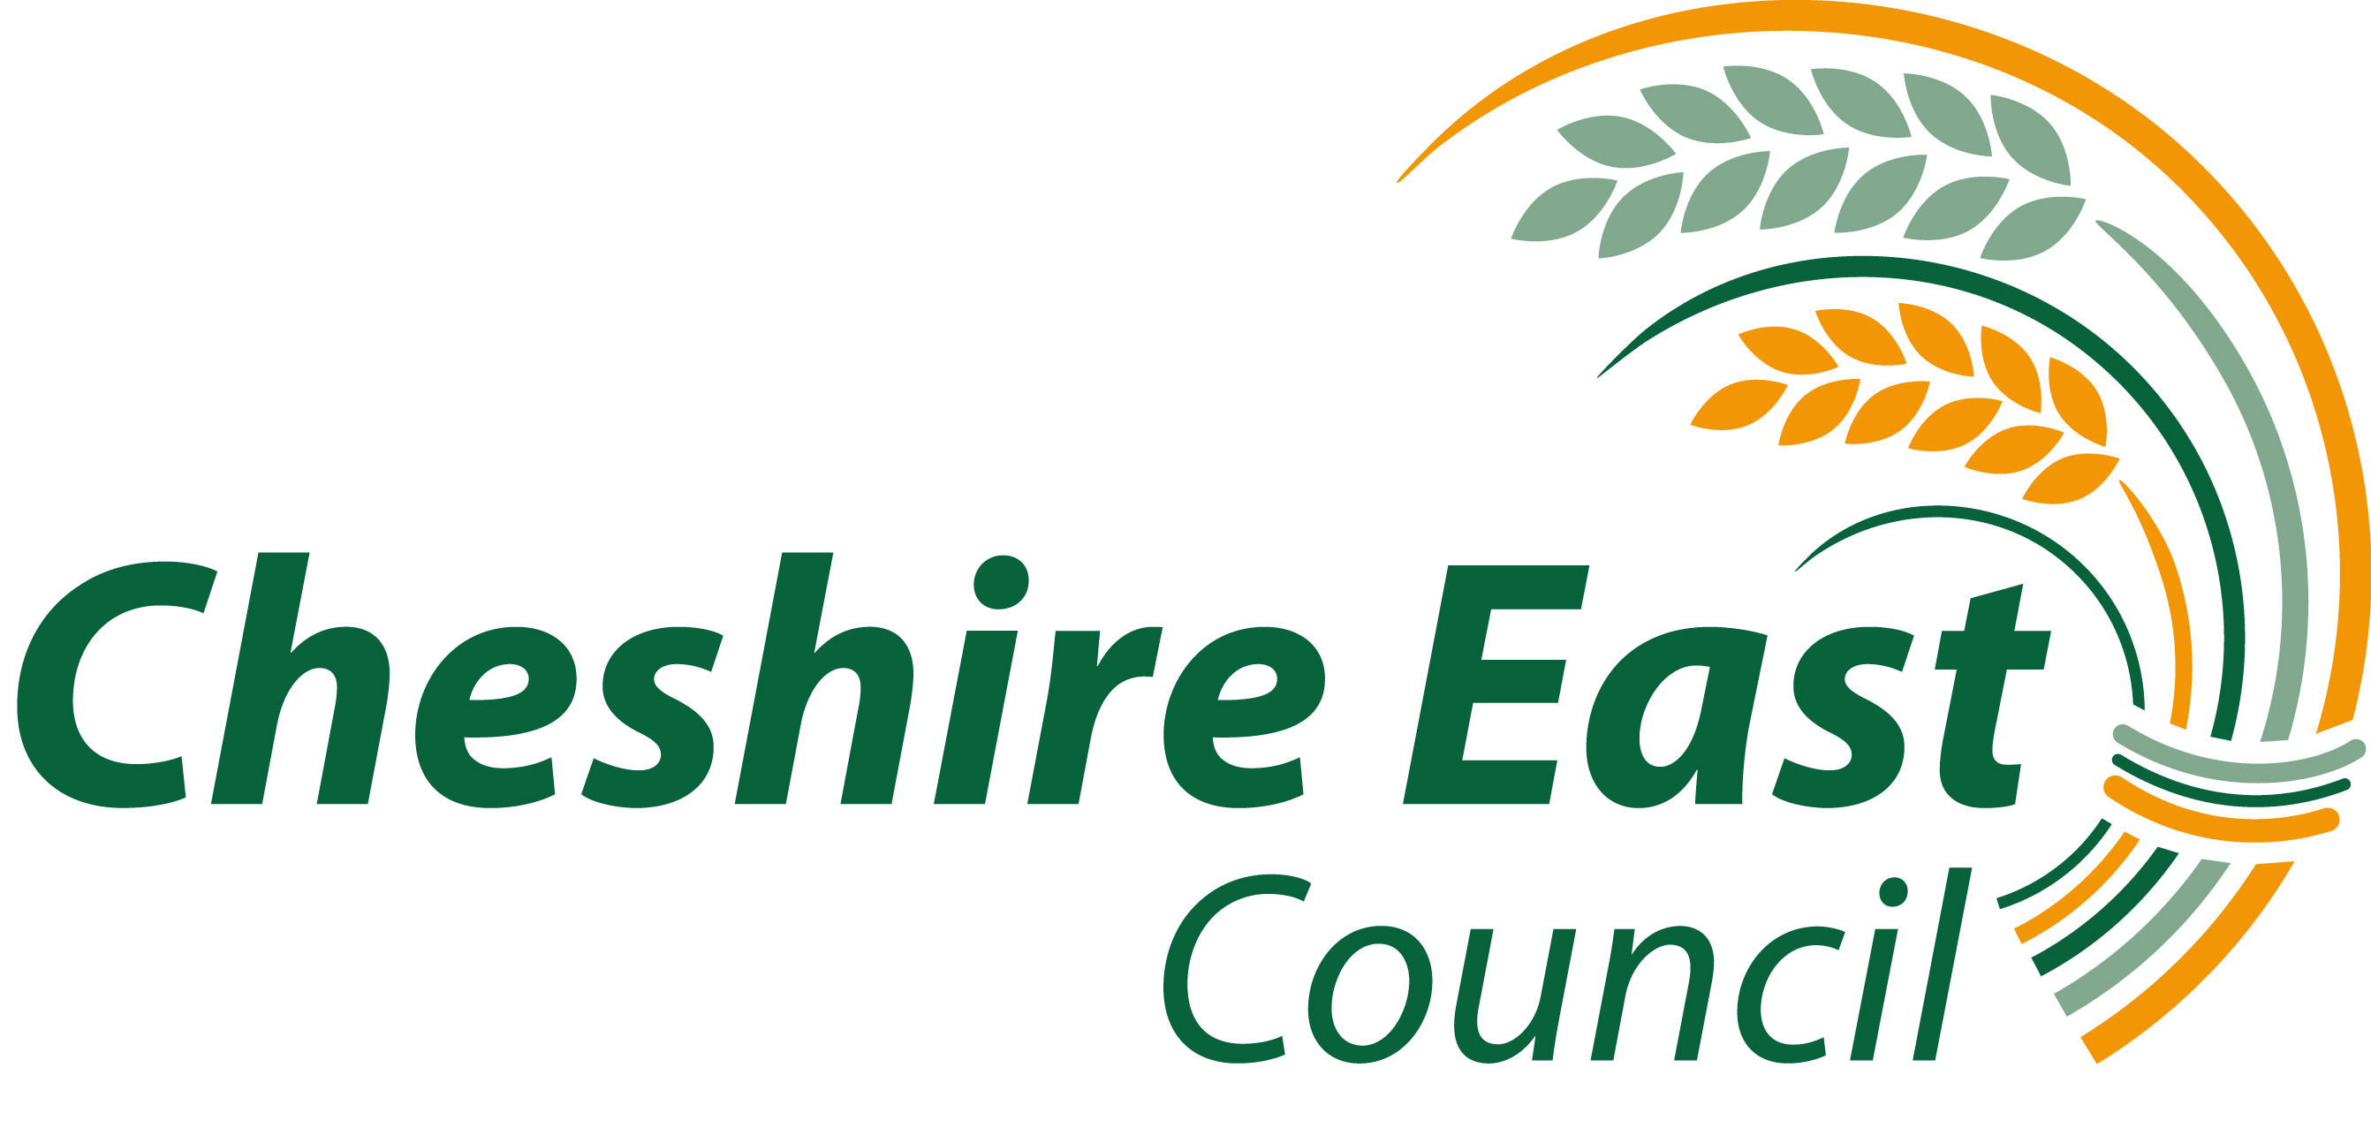

INSTRUMENT OF GOVERNMENT: COMMUNITY SPECIAL SCHOOL

1. The name of the school is Park Lane School

2. The school is a community school.

- The name of the governing body is “ The governing body of Park Lane School “

4. The governing body shall consist of:

(a) 3 parent governors;

(b) 1 LA governors;

(c) 1 staff governor;

- 5 co-opted governors

- 1 Headteacher

- Total number of governors 11

- This instrument of government comes into effect on 17 June 2013.

- This instrument was made by order of the Cheshire East Council on
17 June 2013

8 A copy of the instrument must be supplied to every member of the governor
body ( and the Headteacher if not a governor )

