**Halloween Catalogue 2024**

**Middlewood’s products**

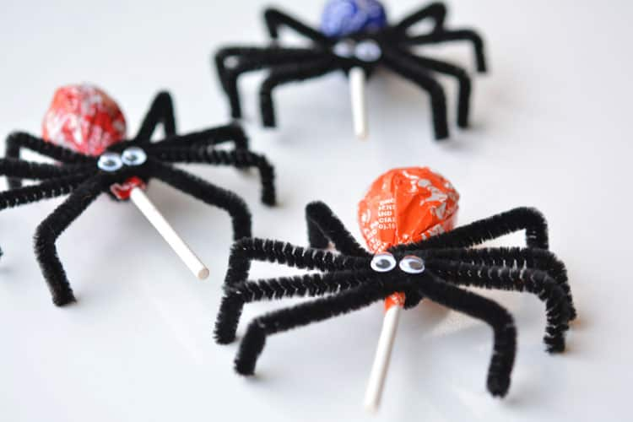Spider lollypops - 50p

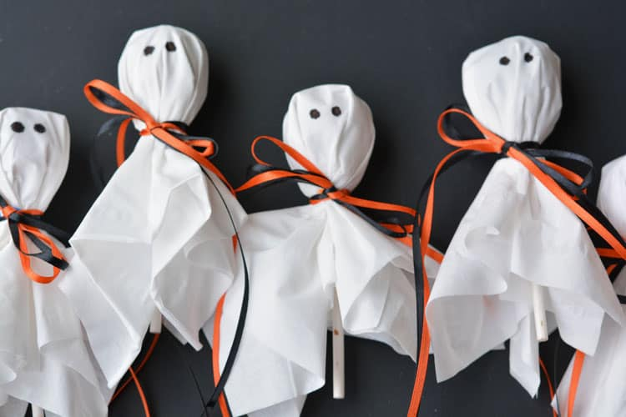Ghost lollypops - 50p

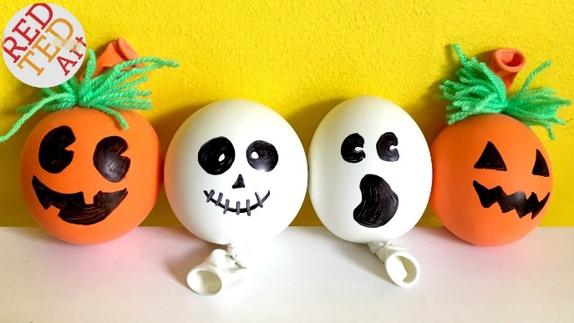Stress balls - £1.

**Bollin’s products**

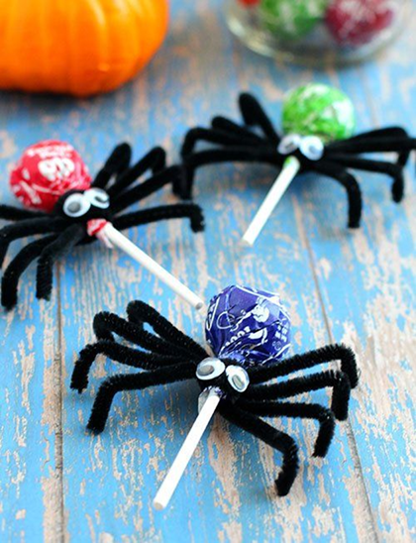Spider sweets-50p Halloween snap bands-£1.

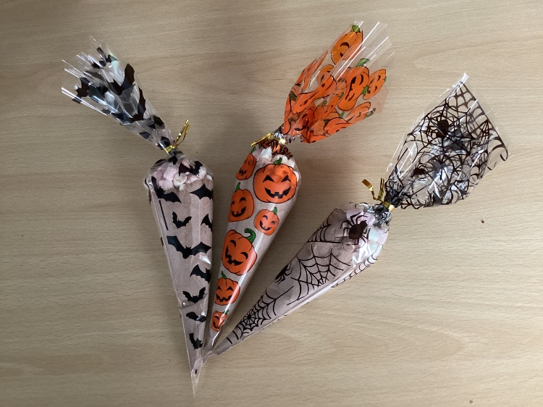**6th Form 1 products**

Halloween Hot Chocolate 50p

And candy cones £1

NO PHOTO

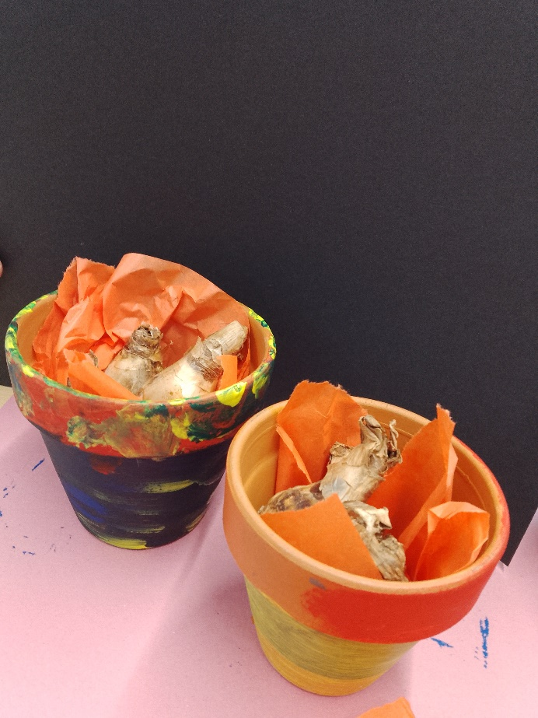**6th form 2’ products**

­­­­Large daffodil pots - £1.50, small daffodil pots - £1.00 - LIMITED STOCK!

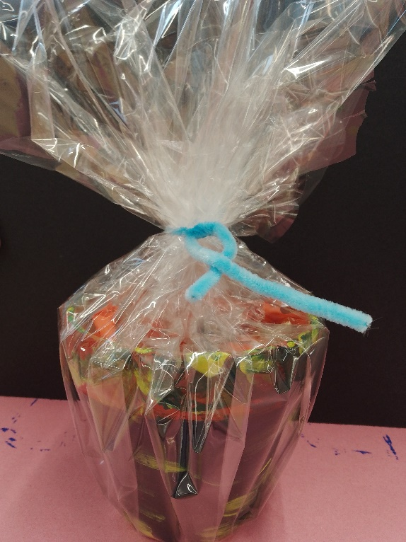

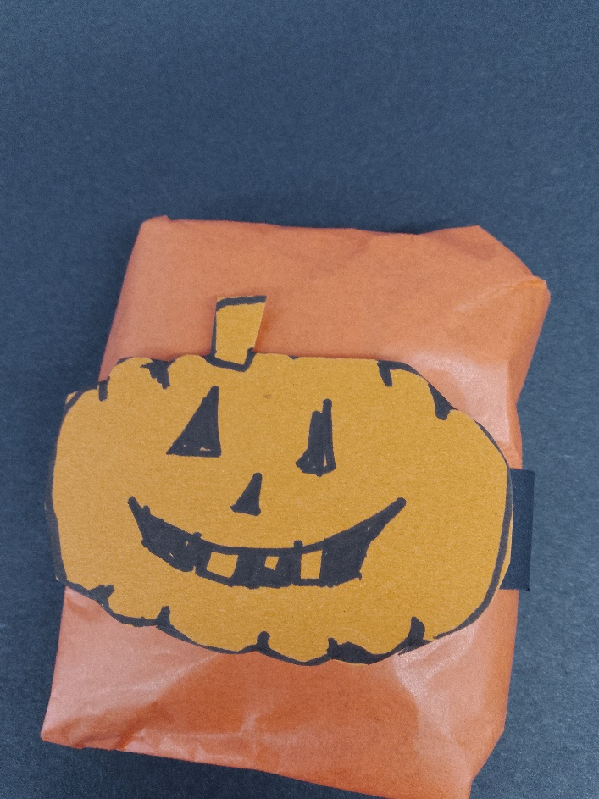

Halloween themed Wrapped sweets - 50p each

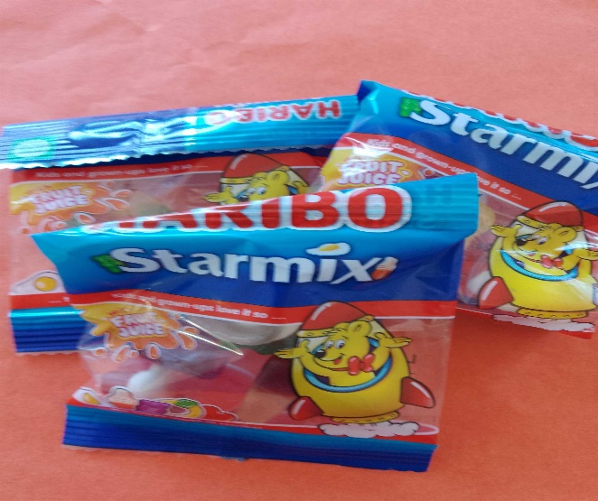

**Treacle’s products**

Windows decorations

One set is £1.50.

Induvial £1

