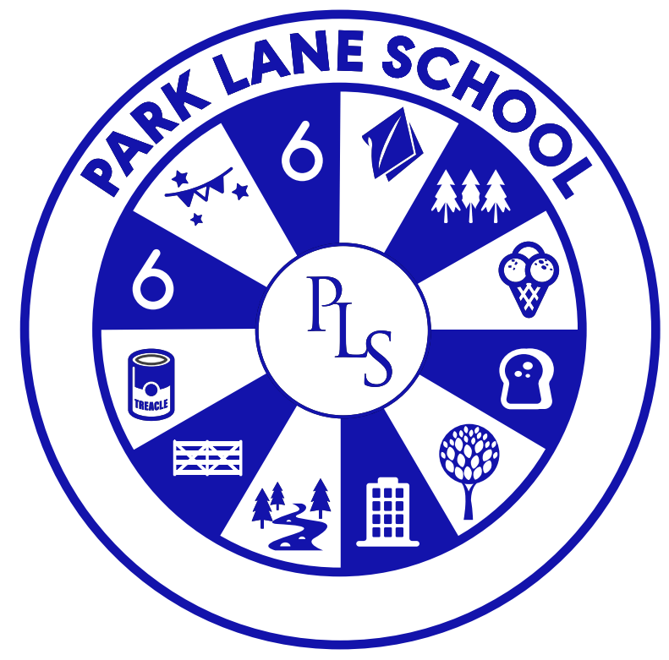

Park Lane School

Person responsible for policy: | Katy Wadsworth
Date approved: | June 22
Review date: | Sept 25

The importance of Personal, Social, Health, Citizenship and Economic Education

“PSHCE education helps pupils to develop the knowledge, skills and attributes they need to manage many of the critical opportunities, challenges and responsibilities they will face as they grow up and in adulthood.
By teaching pupils to stay safe and healthy, and by building self-esteem, resilience and empathy, an effective PSHCE programme can tackle barriers to learning, raise aspirations, and improve the life chances of the most vulnerable and disadvantaged pupils and prepare them for life in modern Britain”

-PSHE Association

Rationale

Personal, social, health, citizenship and economic (PSHCE) education is an important and necessary part of all pupils’ education.

PSHE is a non-statutory subject. Citizenship education is compulsory for pupils in Key Stage 3 & 4. It is important that we, as teachers, deliver high-quality PSHCE adapted to the needs of our pupils at Park Lane School. Each teacher is best placed to understand the needs of their individual pupils and plan their programmes of study accordingly with the support of the subject coordinator.

Our individual PSHE education programmes are designed to equip pupils with a sound understanding of risk and the knowledge and skills necessary to make safe and informed decisions.

“Schools should seek to use PSHE education to build, where appropriate, on the statutory content already outlined in the national curriculum, the basic school curriculum and in statutory guidance on: drug education, financial education, sex and relationship education (SRE) and the importance of physical activity and diet for a healthy lifestyle” [DfE guidelines]

Intent Statement

At Park Lane School PSHCE enables pupils to become healthy, independent and responsible members of society. We encourage our pupils to play a positive role in contributing to the life of the school and the wider community. In so doing we help develop their sense of self-worth. We teach them how society is organised and governed. We ensure that they experience the process of democracy in school through for example the school council. We teach them about rights and responsibilities. They learn to appreciate what it means to be a positive member of a diverse multicultural society.

The aims of PSHE and Citizenship are to enable our pupils to:

- Know and understand what constitutes a healthy lifestyle
- Be aware of safety issues
- Understand what makes for good relationships with others
- Have respect for others
- Be independent and responsible members of the school community
- Be positive and active members of a democratic society
- Develop self-confidence and self-esteem, and make informed choices regarding personal and social issues
- Develop good relationships with other members of the school and the wider community

Rights Respecting Schools
Article 12
Every child has the right to have a say in all matters affecting them, and to have their views taken seriously.
Examples in the PSHCE curriculum: Ongoing teaching of developing self-confidence, respecting views of others and democracy.

Article 15
Every child has the right to meet with other children and to join groups and organisations, as long as this does not stop other people from enjoying their rights.
Examples in the PSHCE curriculum: Ongoing teaching of social skills, identifying likes/dislikes and addressing individual mental health needs.

Article 23
A child with a disability has the right to live a full and decent life with dignity and independence, and to play an active part in the community. Governments must do all they can to provide support to disabled children.
Examples in the PSHCE curriculum: Ongoing teaching of developing independence across aspects of self-care and self-esteem.

Article 29
Education must develop every child’s personality, talents and abilities to the full. It must encourage the child’s respect for human rights, as well as respect for their parents, their own and other cultures, and the environment.
Examples in the PSHCE curriculum: Ongoing teaching of identifying individual likes/dislikes, strengths and areas for development, and tolerance/respect for others.

What opportunities will PSHCE education provide?

Learning PSHE and Citizenship helps all pupils develop as individuals in a wider society. Pupils learn to understand themselves physically, emotionally, socially and sexually and to understand their relationships with others. In particular, PSHE and Citizenship offers pupils with learning difficulties opportunities to:

- Make choices and decisions
- Develop personal autonomy by having a degree of responsibility and control over their lives
- Make a difference or make changes by their individual or collective actions;
- Find out that there are different viewpoints which lead to a respect for the opinions of others

How is the subject taught?
All learning starts from where the pupils are by initially assessing their understanding, misunderstanding or gaps in their knowledge and from there the teachers and class teams will teach and facilitate learning using a range of teaching methods and different forms of curriculum provision

- Discrete curriculum time
- Teaching PSHCE in and through other subject/curriculum areas
- Through PSHCE activities and school events
- Through pastoral care and guidance

Pupils in the Foundation Stage have planned activities and regular routines, which focus on the earliest skills needed for personal, social and emotional development as well as developing physical self-help and self-care skills.

In Key Stages 1 – 5 PSHCE is taught through both termly topics and through daily routines and activities which are ongoing throughout the year. Many areas for example healthy eating and British values are taught in a cross-curricular way. This allows pupils to develop their awareness, understanding and skills through a range of practical activities, which are linked to the topics they are studying.

The delivery of PSHCE is planned for within the Individuality value and schemes of work.

In the 6th Form, pupils follow a life skills-based curriculum and functional PSHCE concepts are taught through everyday ‘real life’ and appropriate activities, which are both cross curricular and subject specific e.g. Health and Wellbeing.

The School Council provides a valuable and authentic platform for learning about Citizenship.

In addition to individual pupil and group activities, school, as a whole, engages in a variety of themed days. This encourages understanding of this important area of the curriculum for example through fund raising events (e.g. Children in Need, Macmillan Coffee Morning, Sport Aid, Comic Relief) and raising awareness of current issues including the recent General Election, World Disasters, The Olympics and Paralympics and Fair Trade.

Pupils throughout the school share weekly assemblies to encourage and promote the development and understanding of key British values for example, Confidence, Peace, Honesty, Respect, Community, Sharing.

RSE (Relationships and Sex Education) is taught through both Science, and through well-planned Personal, Social, Health and Economic education. Teaching of RSE starts in the foundation class and continues through all Key Stages and into 6th Form. (see separate RSE policy)

Long Term Planning

Teachers at Key Stage 1 - 5 have curriculum maps and schemes of work which show coverage across these years. EYFS have their own planning webs taken from the Development Matters framework which is also tracked and monitored for coverage.

The Early Years Foundation Stage Scheme of work is devised by the Foundation Stage teacher and is wholly cross-curricular. The teacher addresses PSHCE through planned activities within Personal, Social and Emotional Development, Physical Development and Understanding the World.

Medium Term Planning
PSHCE is delivered within the Individuality value.

The Early Years Foundation Stage class incorporates PSHE into its medium-term plans through topic related work and daily routines. This may change weekly depending on children’s current interests, cultural and religious celebrations linked to individual families and seasonal changes, which affect the individual children.

Teachers at Key Stage 1 - 4 follow Individuality schemes of work, following their curriculum maps and linked to their class topics. The co-ordinator monitors these schemes of work for coverage and delivery. Citizenship Schemes of Work for Key Stage 3 & 4 are developed in conjunction with class teachers and the subject coordinator.
In addition, KS3 work through units form the New Horizons workbooks.

Students in the 6th Form work on units of work from an externally accredited qualification. There are several of these which link into areas of PSHCE. For example, Dealing with Problems, Developing Independent Living Skills, Keeping Safe, Personal Presentation, Developing Skills for the Workplace, Being Healthy.

Short Term Planning

Details of individual lessons for the whole class, groups or individuals are included on each class’s weekly Forward Plan and lesson plans are written as required. A lot of PSHCE takes place within other subject areas and throughout the daily routines. It is not always taught as a discrete lesson.

Assessment and Progress

Pupil achievements, progress and experiences in PSHCE are recorded by the class teams through Records of Achievements, Learning Journeys (Foundation Stage) and completing the assessment tool B Squared which is currently based on Engagement and Progression Steps and EYFS Early Steps. Teachers use the Lanes to help set appropriate, relevant objectives and expected outcomes in PSHCE for individual pupils and to record progress over the terms. The teacher assessment and feedback is read by the PSHCE lead at the end of each term and academic year.

Students in the 6th Form focus on units of work from an externally accredited qualification which are recorded in their individual files for accreditation.

Monitoring

The subject coordinator supports colleagues in the teaching of PSHE and Citizenship by giving them information about current developments in the subject and by providing a strategic lead and direction for the subject in the school.

All teachers are asked to give the co-ordinator feedback on the termly schemes of work so the co-ordinator can note coverage and any problems there may have been in delivering schemes of work. SOW are written for Key Stage 3 and 4 in Citizenship, where requested. The coordinator has access to all teacher files, on the school server, in order to access long, medium- and short-term planning as well as records held within the B Squared assessment tool, which allows for regular monitoring of the subject.

Resources

All resources linked to this area of study are to be found in a cupboard in the Staff Room. These resources are organised into topics covering a wide range of relevant subjects. There are a lot of resources which are readily available online. The co-ordinator can signpost class teachers to specific websites on request.

Equal Opportunities

Teaching will take into account the ability, age, readiness and cultural backgrounds of our young people and those with English as a second language to ensure that all can fully access PSHCE education provision. The PSHE, Citizenship and RSE work that is carried out in school is always of a practical nature and is dealt with in a sensitive and empathetic way. This ensures that all students can take part. RSE for the older pupils is taught in single sex groupings by an experienced HLTA who knows the pupils and their specific needs. Permission from parents/carers is always required before any RSE lessons are taught. The resources are monitored to ensure they are appropriate to the students and class teachers can approach the co-ordinator to request specific equipment or resources if needed for specific pupils.

Preparing for Adulthood

All schemes of work have a strong thread of activities and desired outcomes that support Preparing for Adulthood. Our primary aim for all our pupils is to equip them with skills for life beyond Park Lane School. PSHCE plays a big part in this with importance on teaching students how to be safe, how to look after themselves, how to stay fit and healthy, how to manage their mental health and ultimately how to live with as much independence as possible.

Reporting to Governors

The co-ordinator writes a short report if requested by the Chair of Governors or Head teacher to inform Governors of any progress and achievements in this subject area.

This policy was updated in June 2019. Amendments added September 2020 then April 2021. Edited June 2022 by Katy Wadsworth (COVID precautions removed)

Katy Wadsworth

NB This PSHE and Citizenship policy should be read in conjunction with the other school policies.

