Assessment at Park Lane School

With a change in the guidance around assessment for pupils with special needs, it was de- cided that the school system of assessment needed an overhaul, both in how evidence was recorded and what we recorded. After research and trials, it was decided that school would create their own system, using a range of ideas and concepts, together with guid- ance, the early years development matters and the national curriculum. The digital system ‘Evidence for Learning’ is being used to record this.

Pupils with the most profound and complex needs are now assessed on the Engagement model. The government understands that these pupils need to focus on the priority needs of their EHCP and so all their learning and assessment comes under the sections ‘Communication and Interaction’, ‘Cognition and Learning’, ‘Social, Emotional and Mental Health’, ‘Independence and Life Skills’ and ‘Physical and Sensory’. The framework produced is also not completely linear, as pupils working at this developmental stage often have spikey profiles due to sensory needs or physical disabilities. The framework allows for a broad and balanced curriculum whilst focusing on the needs of the learners in question.

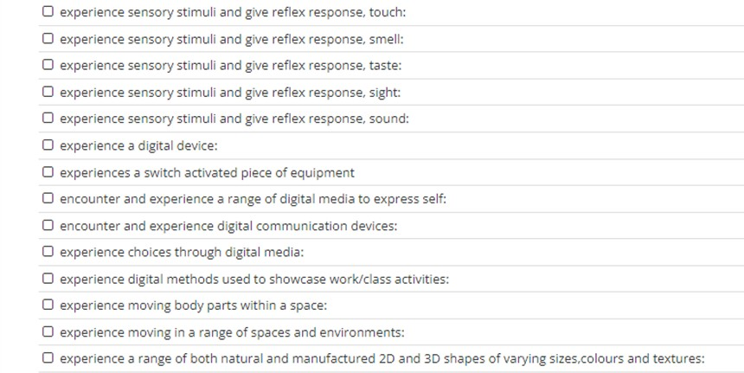Below are examples from our Non-subject Specific Framework. Pupils can work at a range of levels on each skill, emerging, developing, secure and mastered.

Cognition and Learning

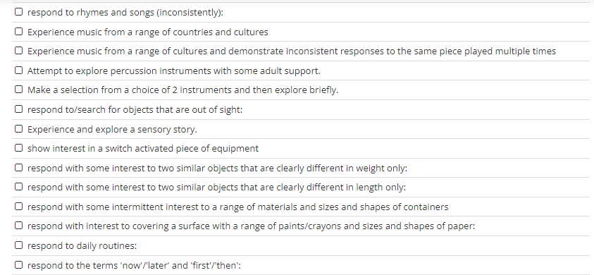

Communication

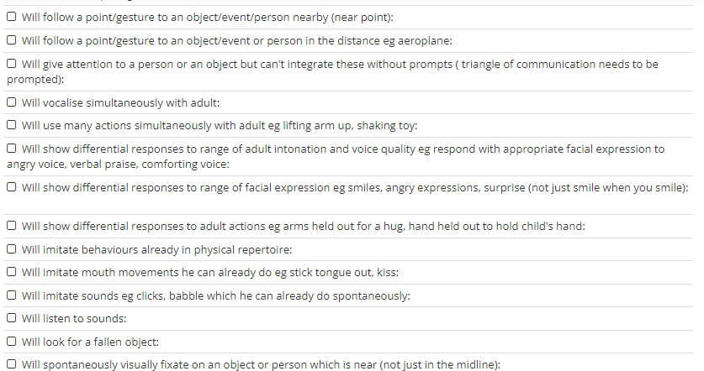

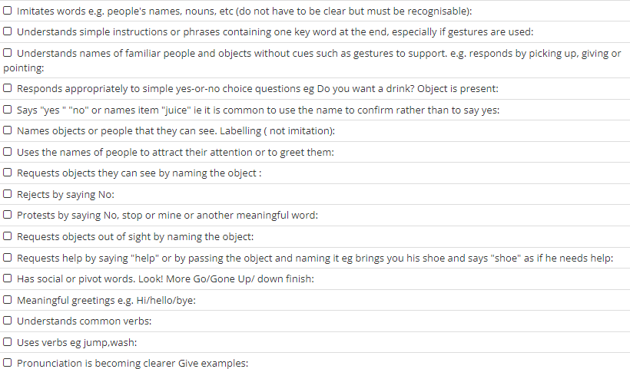

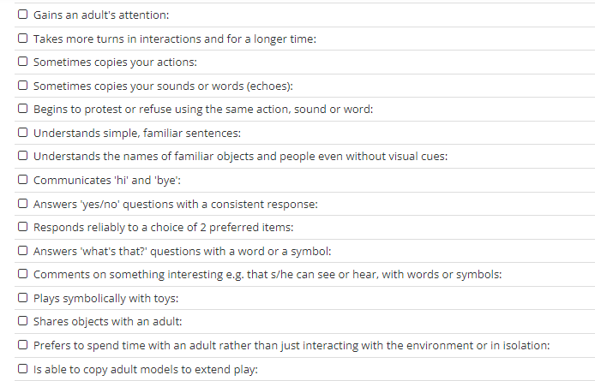

SEMH + Independence and Life Skills

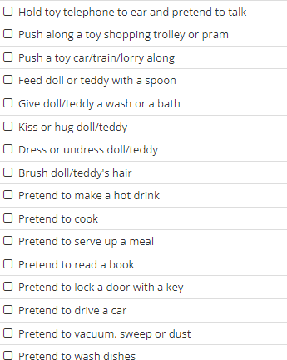

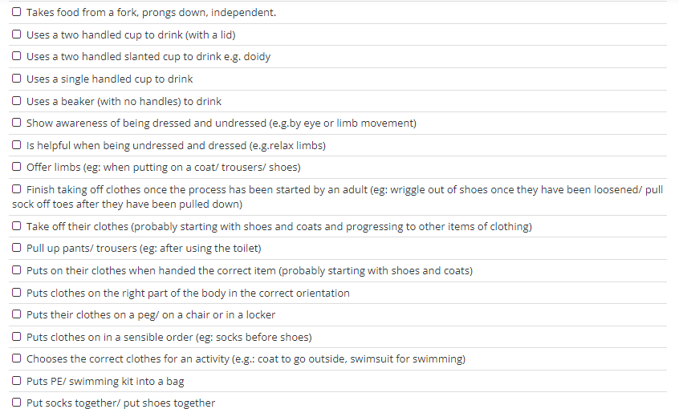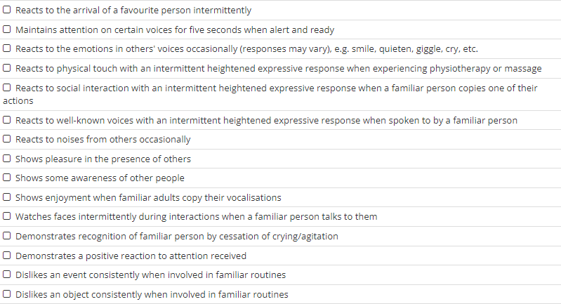

Physical and Sensory

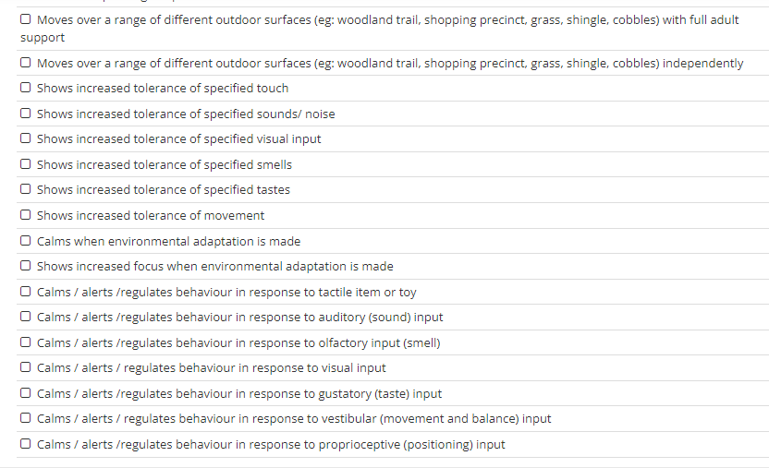

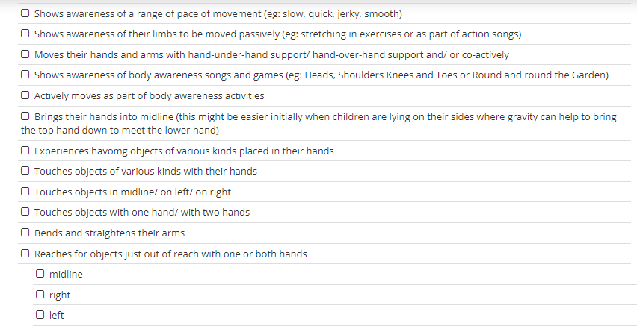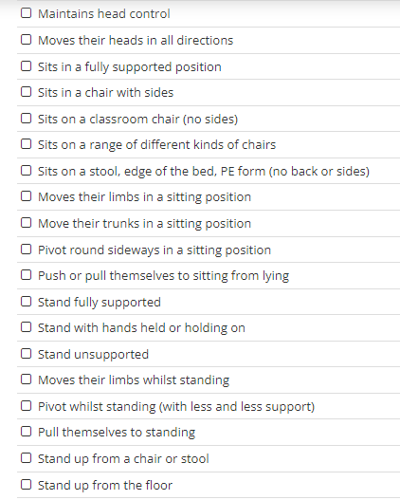

For pupils working above the Non-Subject Specific framework, there are now ‘Lanes’ of

learning for Maths, English and our Values areas– Creativity, Community, Challenge and In- dividuality. These values areas encompass all subjects of the national curriculum and the

lanes provide a sequential building of skills and knowledge right up to the level of some- one working at the age related expectations for a year 6 pupil. Pupils can work in a range of lanes, depending on needs, abilities, difficulties and interests. The Park Lane curriculum allows for a broad and balanced learning and experiences which can then be assessed us- ing these Lanes. Again, students can be working at different levels for each statement,

emerging, developing, secured and mastered. Below are examples from each of the areas.

English

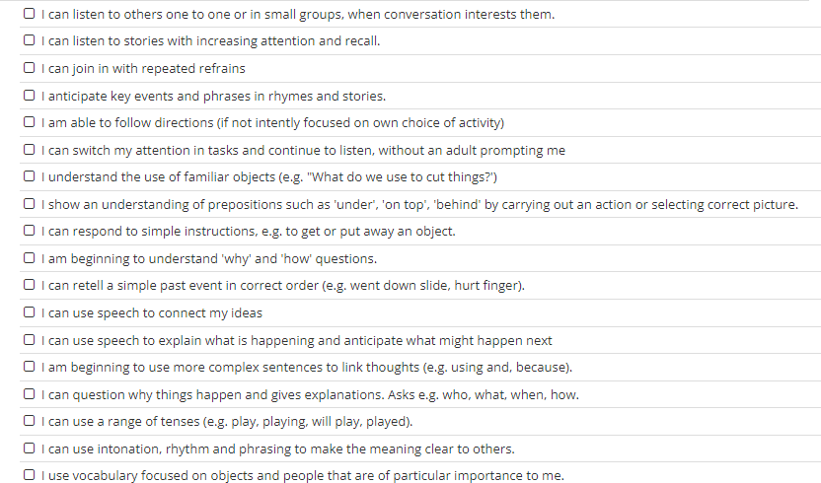

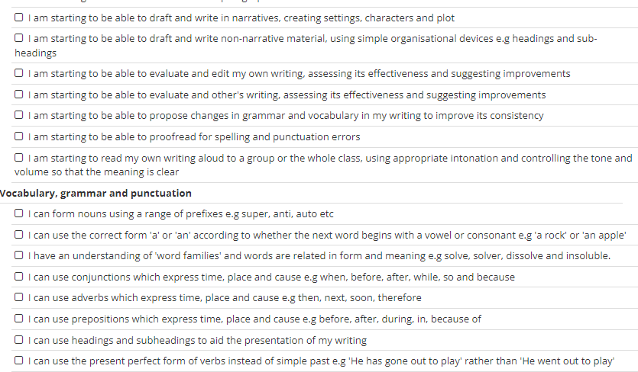

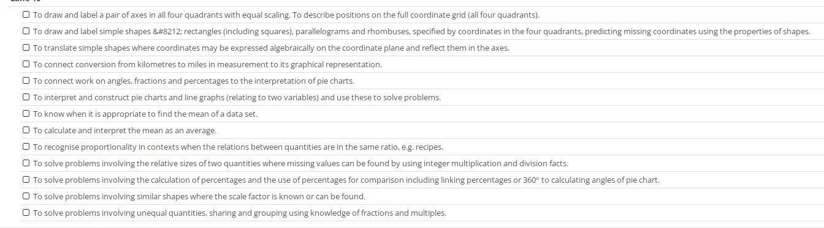Maths

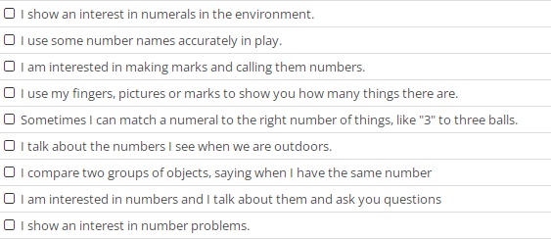

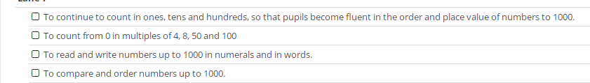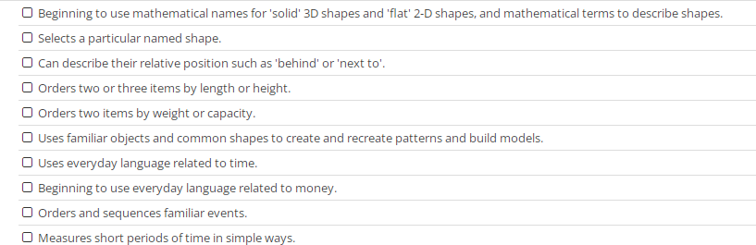

Challenge

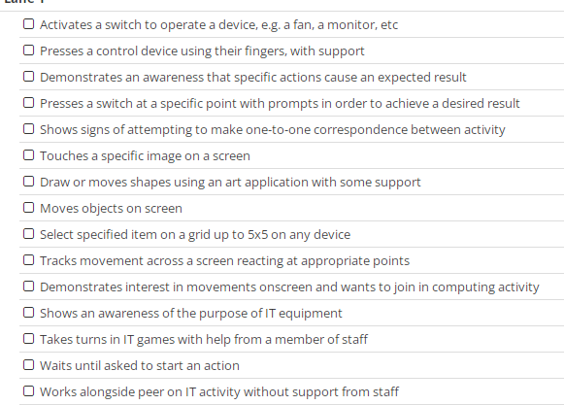

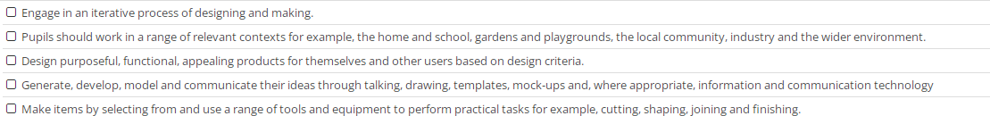

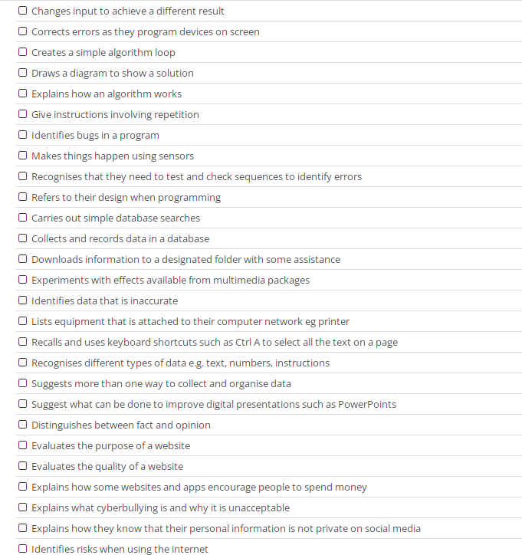

Community

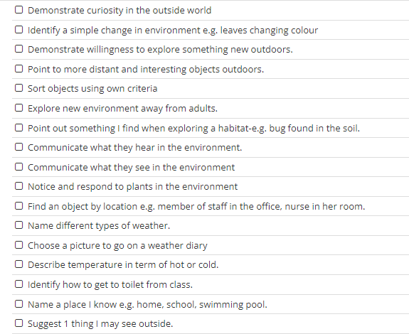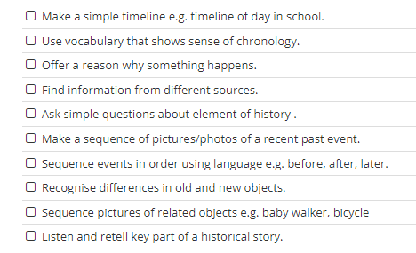

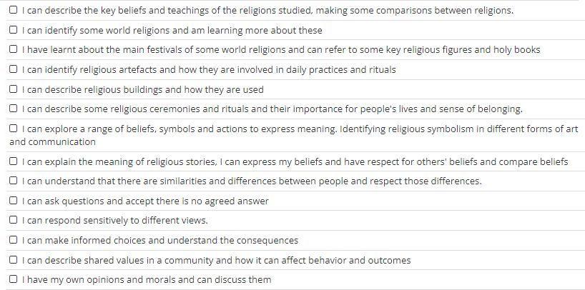

Creativity

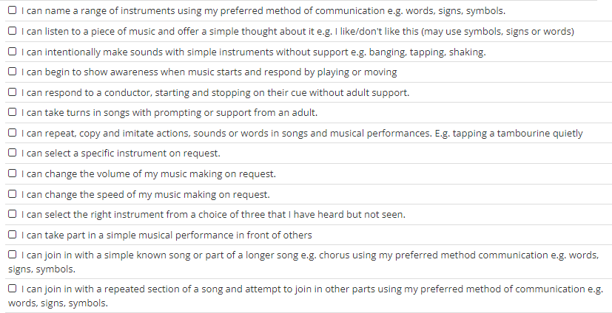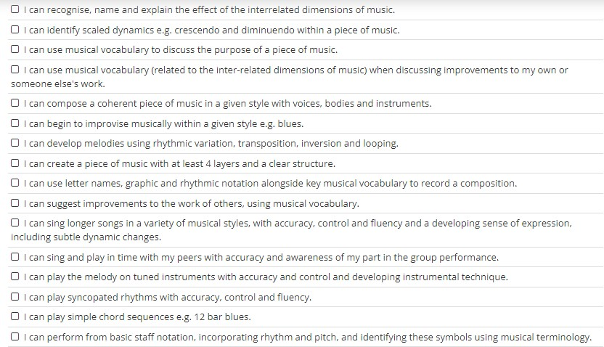

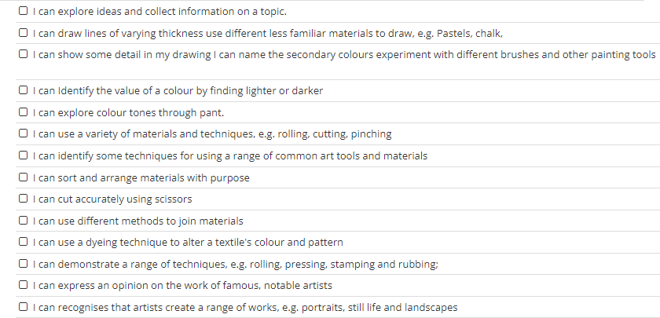

Individuality

