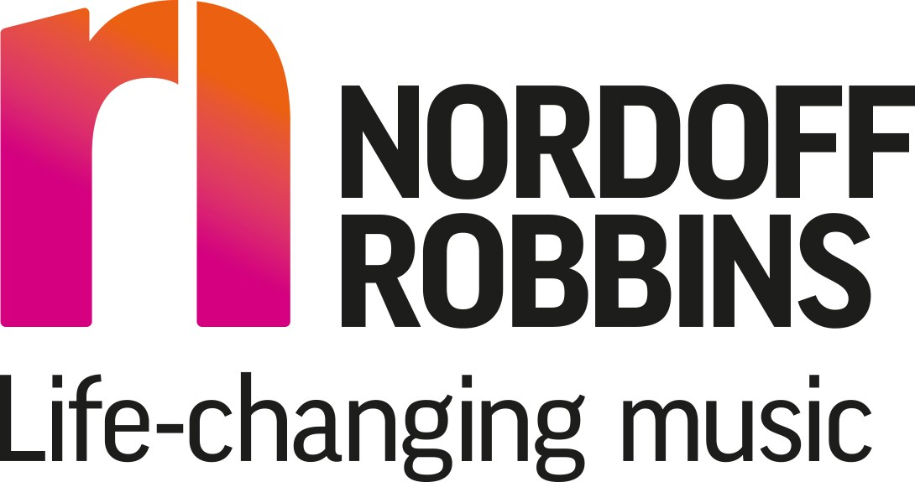Nordoff Robbins Music Therapist Role at Park Lane School

Music therapy at Park Lane School is provided on Tuesdays and Fridays by music therapists Brooke Hirst from Nordoff Robbins, the largest independent music therapy charity in the UK. Both music therapists have been trained in the Nordoff Robbins approach to music therapy which places interactive music making at the heart of the therapeutic process. Nordoff Robbins music therapists hold the value that everyone can respond to and engage with music and that in doing so, musical interaction can support pupils to achieve, create, respond, share, interact, connect, learn and experience themselves in new and different ways. Music can be fun, engaging and playful and often provides an alternative method of connection and interaction for those with severe communication difficulties, complex health needs and/or challenging behaviour.

The music therapists at Park Lane work with pupils both individually and in groups to achieve specific aims and objectives which are unique to the needs and abilities of each person involved. These aims are often developed in collaboration with teachers, support staff, speech and language and occupational therapists. Felicity and Kate also aim to be a musical presence within the school on the whole. This may include providing additional music therapy sessions with whole classes or larger groups, musical activities such as singing and signing and contributing to school events such as Christmas performances and Arts week.

Referrals to the music therapy service are discussed with the music therapists who then organise sessions in collaboration with the head teacher and teaching staff. The length and duration of sessions will depend on the individual needs for each pupil or group. This may involve some pupils attending music therapy in blocks with a break in between, whilst others will attend continually each week throughout the year.

All music therapy takes place on the school premises during school hours. The music therapists deliver approximately 8 sessions per day, each lasting about 30 minutes.

# What is music therapy?

Music therapists use the medium of music not to teach musical skills, but to provide support for a pupil’s social, physical, communicative and emotional development. As a non-verbal medium, music therapy can be particularly effective at offering those with language and communication difficulties an alternative way of interacting, socialising and expressing themselves. Interactive music-making with a music therapist can improve attention span, listening and turn-taking skills, as well as physical skills such as grasping and coordination. Music therapy can also offer pupils the opportunity for success and achievement and thus often leads to improvements in self-awareness and self-confidence.

During both group and individual sessions, pupils are encouraged and supported by the music therapist to use and create music in a way that is accessible and appropriate to their needs and abilities. This may involve anything from gentle movements accompanied by music, to writing songs or singing and playing a wide variety of instruments. A mixture of structured pre-composed music and improvised music is used: the former often helps to hold and develop concentration, anticipation, memory and turn-taking, whilst the latter encourages self-expression, exploration and decision-making.

# Who may need music therapy?

Some example reasons for referral are;

* Communication and social interaction difficulties
* Difficulties with change and transition
* Emotional and behavioural difficulties
* Low self-esteem and low self-confidence
* Difficulties relating to others and forming relationships
* Concentration difficulties and short attention span
* Lack of independence and autonomy
* Withdrawn or particularly anxious students
* A pupil who finds it difficult to play/initiate
* Over-sensitive/under-sensitive to stimulus

[Nordoff and Robbins - The UK's largest music therapy charity (nordoff-robbins.org.uk)](https://www.nordoff-robbins.org.uk/)