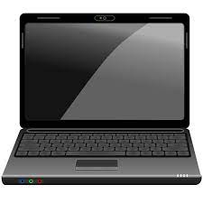ICT Club

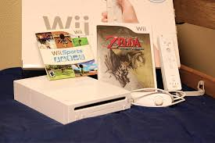

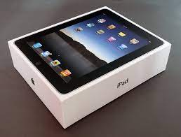Thursdays

Ipads – Laptops – Nintendo wii – DS – PC – Music

1.00pm – 1.30pm

In the ICT room