Easter Markets 2024
Middlewood’s products
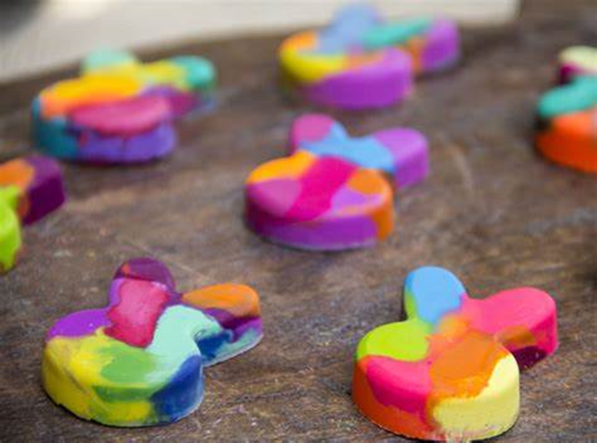
Eastern Wax Crayons – 50
p

Easter Egg Chocolate - 50p
Treacle’s products

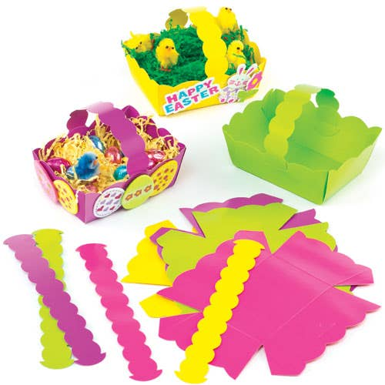
Small and large Easter baskets filled with Easter Treats (50p and £1)

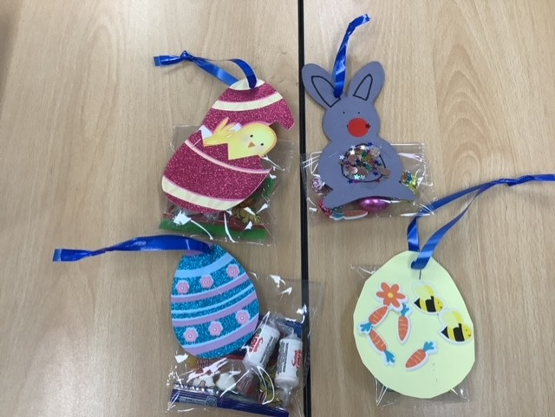
Arighi’s products
Easter sweet and
treat bags- £1.50 each.

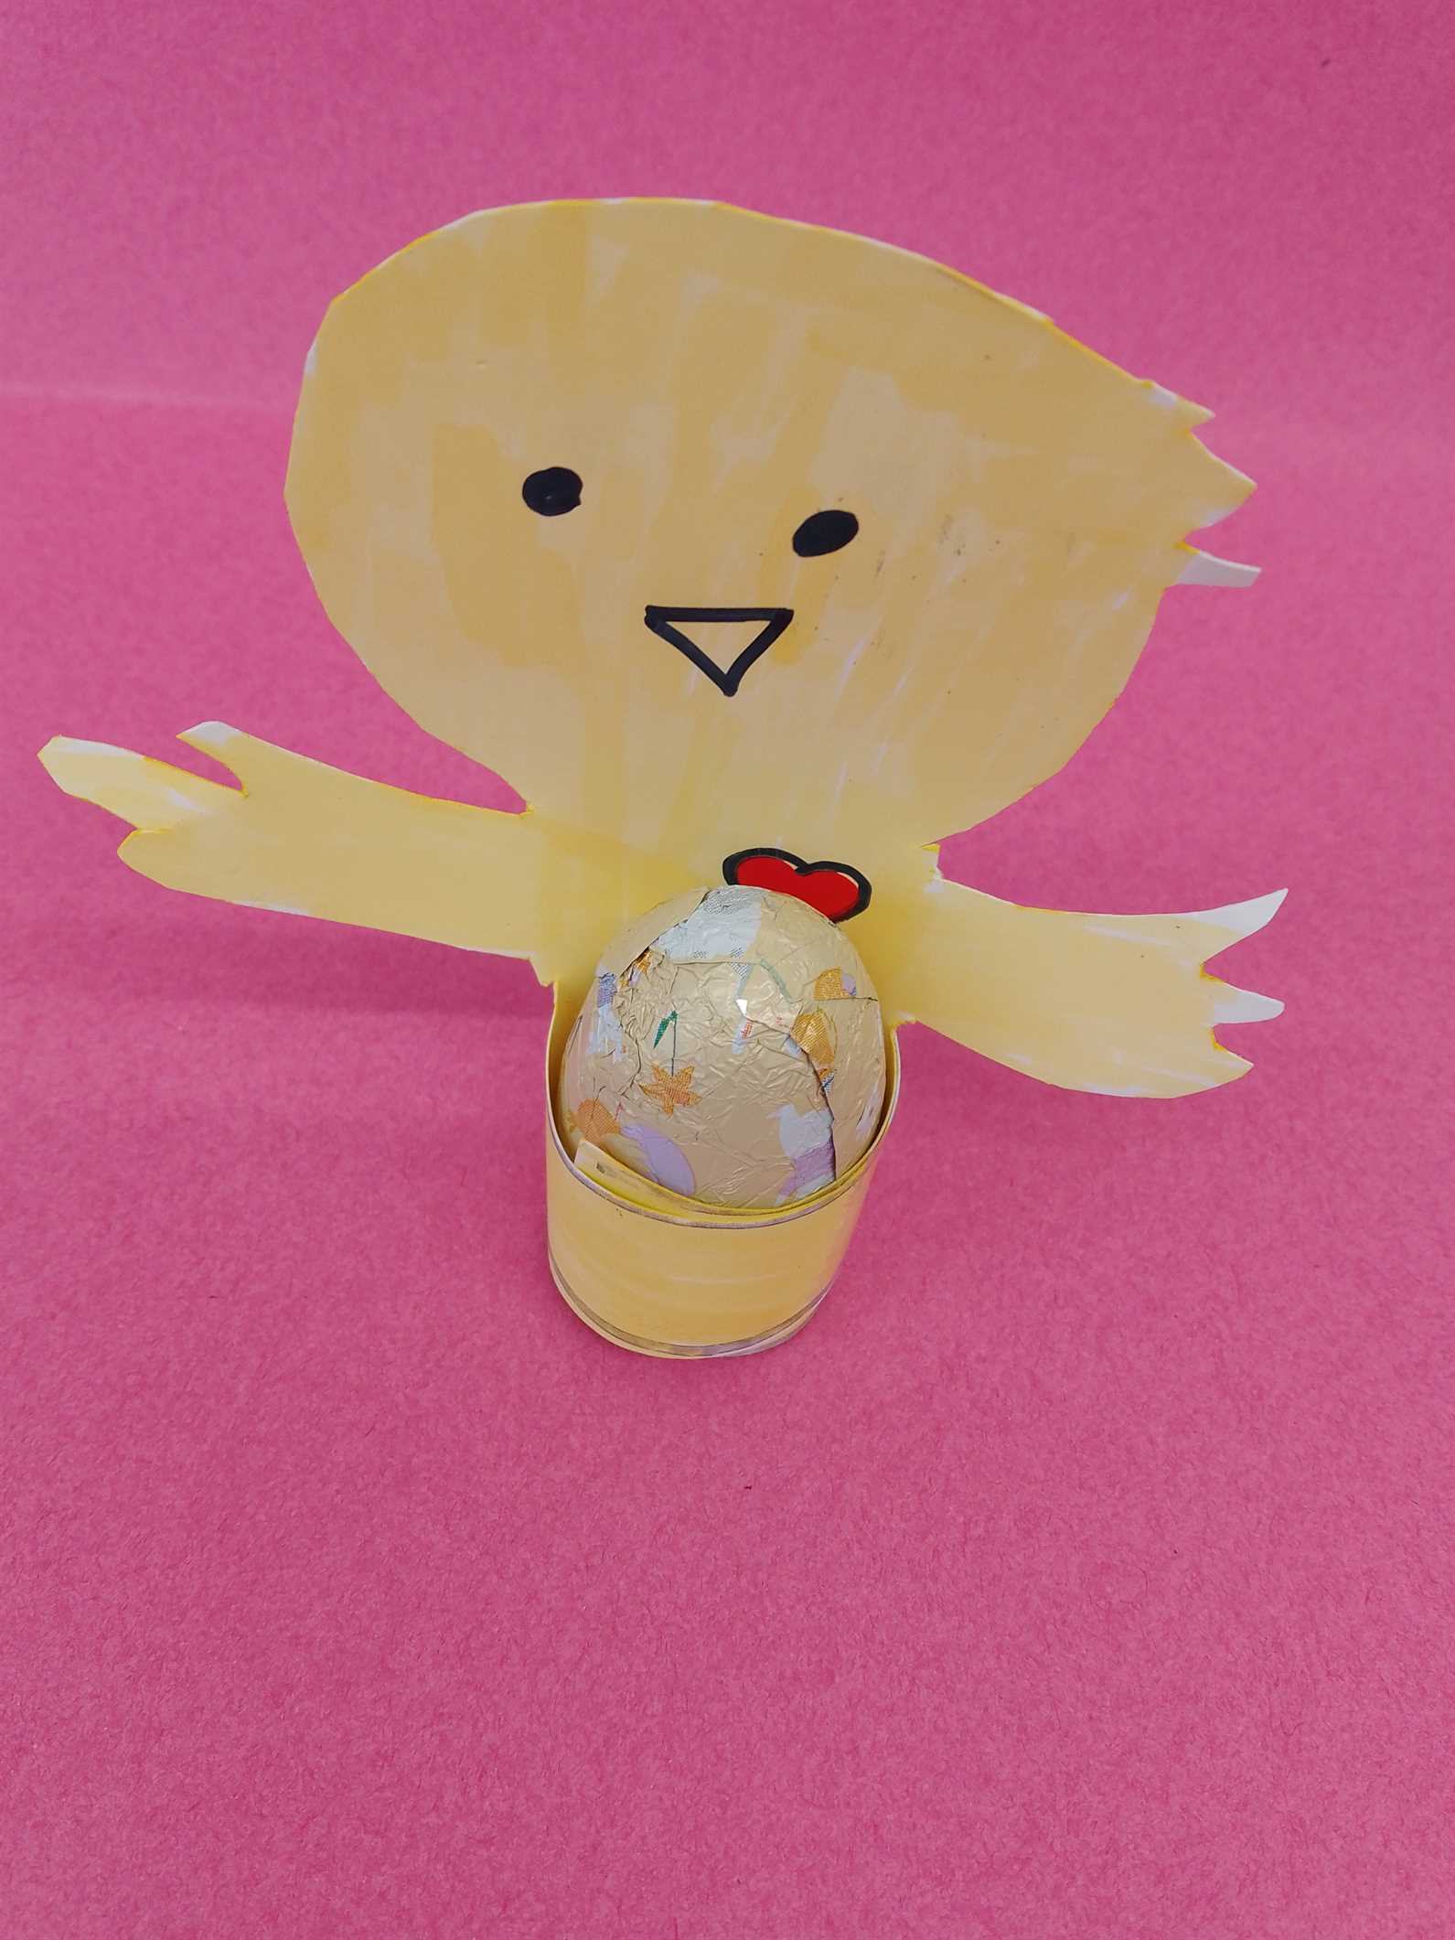
6th Form’s products
Easter chick egg
50p

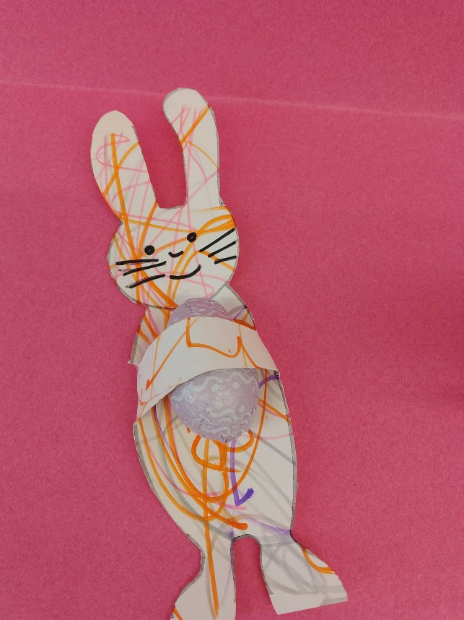
Wrapped Sweets 50p.
No photo

6th form 1 product
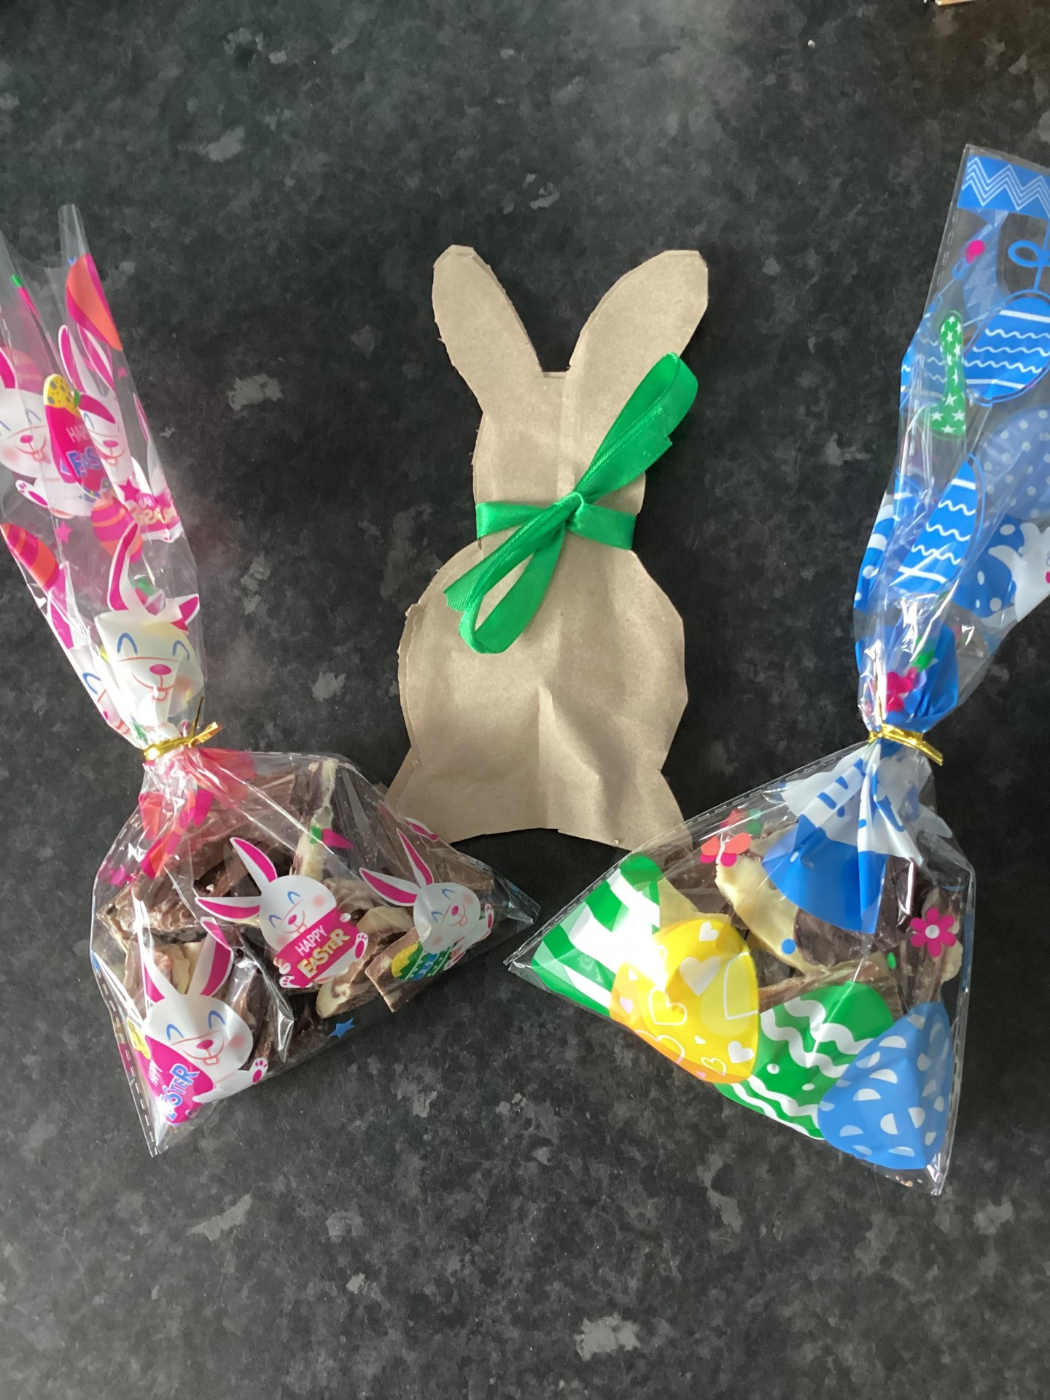
Bunnies are 25p and chocolate bark bags are £1.

Bollin’s products

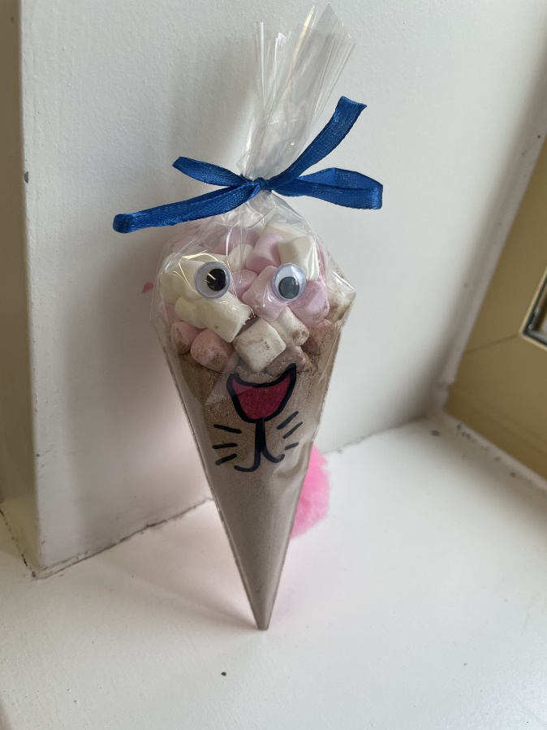
Hot Chocolate Bunnies £2

