Christmas catalogue

Arighi’s Products
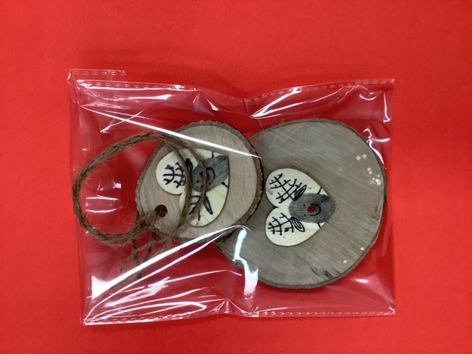
Christmas tree decoration £1.00 each

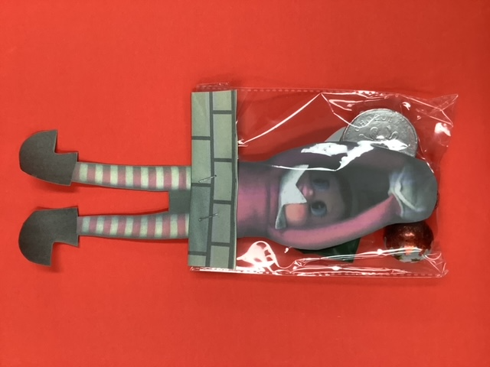

Naughty or Nice Sweetie pack- includes sweets, balloon, sticker £1.00 each.

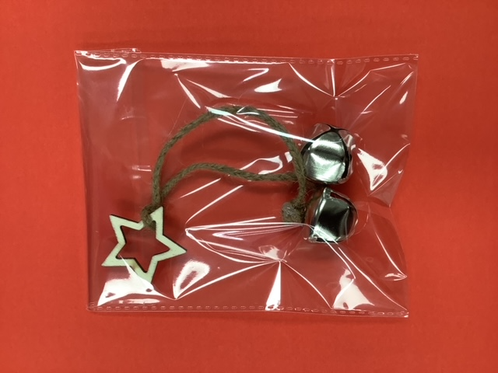
Bell tree decoration
£1.50

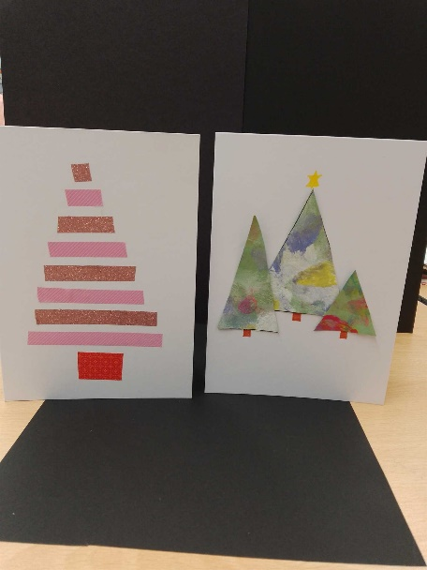
6th form 2 Products

Christmas cards £1.50

Wrapped sweets - 75p each.
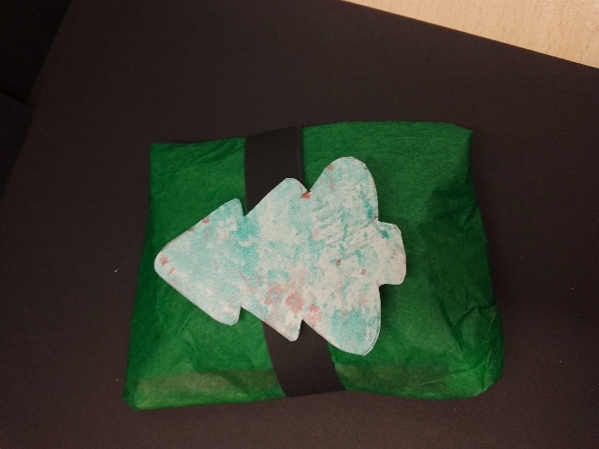

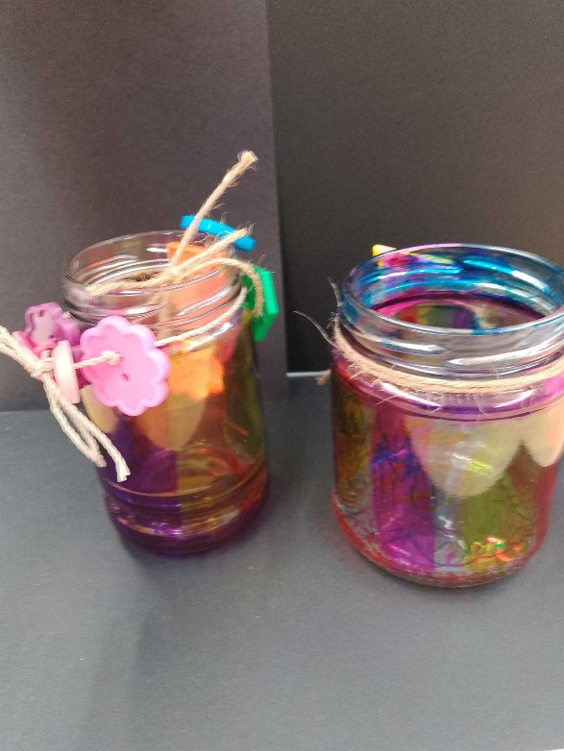

Glass candle jars - 50p small / 75p large

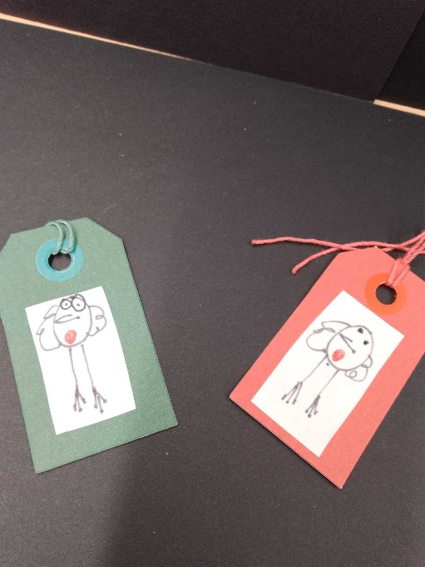
Christmas tags - 25p each

6th Form 1

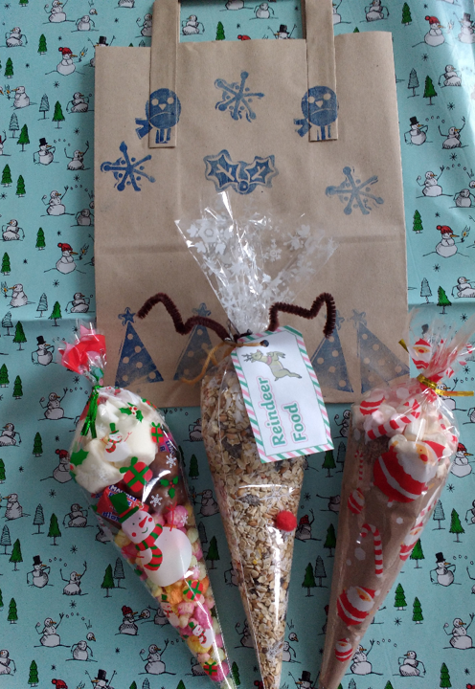

Sweet bags £4

Treacle’s products
Christingles
£1.50
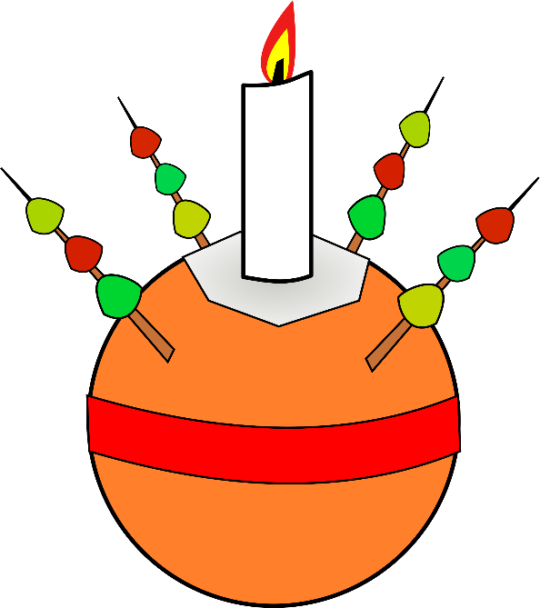
Bollin’s products
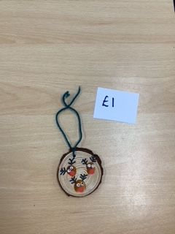
Tree decorations

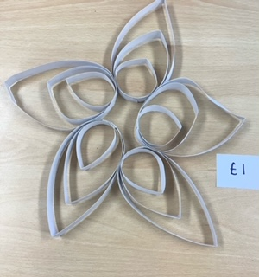

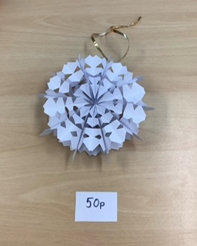
Hanging decorations
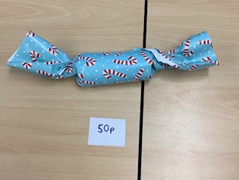

Sweets crackers
Snowflakes decorations

